**Consider the below two tables**:

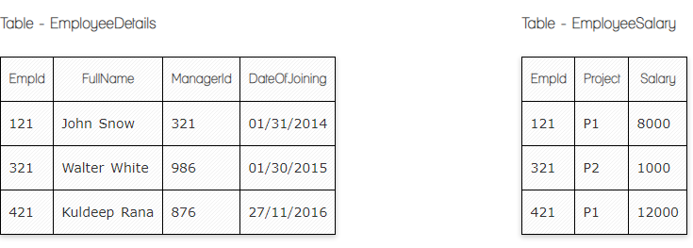

**Ques.1. Write a SQL query to fetch the count of employees working in project 'P1'.**

**Your Answer:**

Select count(EmpId) from EmployeeSalary

Where Project = “P1”;

Select count(Project)

From EmployeeSalary

Group By Project

Having Project = ‘P1’;

**Ques.2. Write a SQL query to fetch employee names having salary greater than or equal to 5000 and less than or equal 10000.**

**Your Answer:**

Select ed.FullName from EmployeeSalary es

Inner join EmployeeDetails ed On es.EmpId = ed.EmpId

Where Salary between 5000 and 10000

Where Salary >= 5000 and Salary <= 1000;

**Ques.3. Write a SQL query to fetch count of employees sorted by project's count in descending order.**

**Your Answer:**

Select count(EmpId), Project from EmployeeSalary

Group by Project

Order by count(EmpId) DESC;

**Ques.4. Write a SQL query to fetch all the Employees details from EmployeeDetails table who joined in Year 2016.**

**Your Answer:**

Select * from EmployeeDetails

Where DateOfJoining like ‘%2016’;

**Ques.5. Write a SQL query to insert new record to the EmployeeDetails table with any data.**

**Your Answer:**

INSERT INTO EmployeeDetails (FullName, ManagerId, DateOJoining)

VALUES (value1, value2, value3);

**Ques.6. Write a SQL query to update EmployeeSalery table with setting Salary to 2000 for Project P2.**

**Your Answer:**

UPDATE EmployeeSalery

SET EmployeeSalery.Salary = 2000

WHERE EmployeeSalery.Project=’P2’;

**Now take these two tables:**

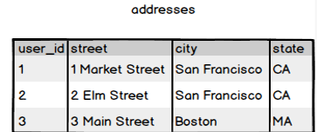

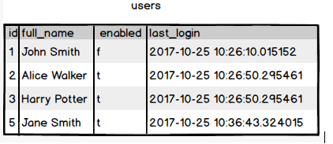

**Ques.7. Write a SQL query to fetch all users full_name from San Francisco.**

**Your Answer:**

Select full_name from addresses a

Inner join users u on a.user_id = u.id

Where city like ‘%San Francisco%’;

**Ques.8. Write a SQL query to fetch all users full_name who are not from Main street**

**Your Answer:**

Select full_name

From users

Inner Join addresses

On user.id = addresses.user_id

where not street='Main street';

**Ques.9. Write a SQL query to fetch all users full_name who are from Main street or San Francisco**

**Your Answer:**

Select full_name

From users

Inner Join addresses

On user.id = addresses.user_id

where street = 'Main street' or city = 'San Francisco';

**Ques.10. Write a SQL query to fetch user full_name who is equal to user_id from Boston (find user_id value in sub_query)**

**Your Answer:**

Select full_name from users

Where id in (Select user_id from addresses

Where city = ‘Boston’)